THE MEXICO EQUITY AND INCOME FUND
AGENDA

- Performance
  - Please could you provide a review of MXE’s NAV performance for the 12-month period ending 31-Jul-17? Please cover the largest contributors and detractors, in terms of sector and stock selection; what drove their performance; and whether any changes were made to the portfolio as a result?
Our assessment reports register a -622-basis points underperformance compared to the Mexbol-Index’s return for the one-year period ended July 31, 2017, resulting mainly from a more than 300 basis point negative contribution from the Wireless Telecommunications Services and Beverages industries, which have the highest per stock concentration in the Mexbol -Index with weights of 13% and 16.6%, respectively. The Fund remains adhered to a maximum 10% weight in individual stocks and to a de-indexed investment strategy. (Source: PAM and Bloomberg).
The period from November 2016 to January 2017 showed the greatest volatility in the Fund’s NAV in the one-year period ended July 31, 2017, following a -9.45% local currency depreciation versus the U.S. Dollar in same period. (Source: Bloomberg)
MXE’s US Dollar Return with Dividends Reinvested
Sources: U.S. Bancorp¹; Thomson Reuters²; PAM³; Bloomberg.

MXE NAV Comparison Base 100 in US Dollars
(12/31/2008 – 07/31/2017)
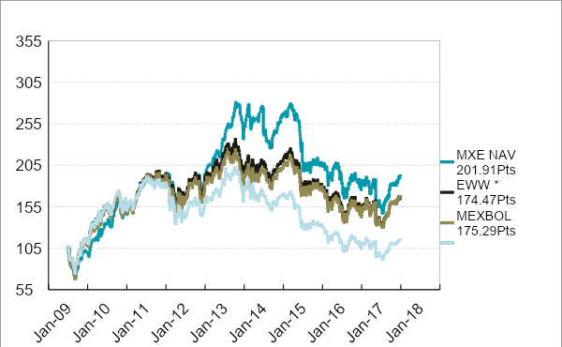
Source: PAM and Bloomberg.

The largest contributors to the Fund’s 12-month performance by sectors were Telecommunication Services, Financials, and Materials, with 4.38%, 2.91%, and 1.89%, respectively. There were no sector detractors in the referred period.
MXE's 1-Year Relative Contribution by Sectors
As at July 31, 2017.
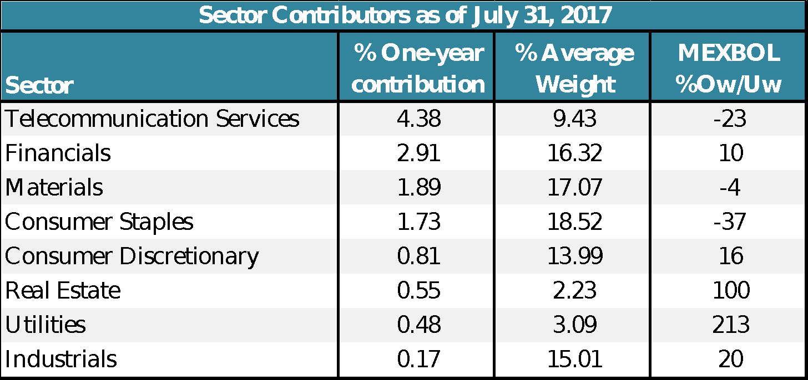
Sources: PAM and Bloomberg.
In the case of Telecommunication services, the sector posted a strong recovery supported by a turnaround in quarterly results, rational competition, and regulatory easing with limited upside to our target price and the consensus.

America Movil Financial Results as of 2Q’17
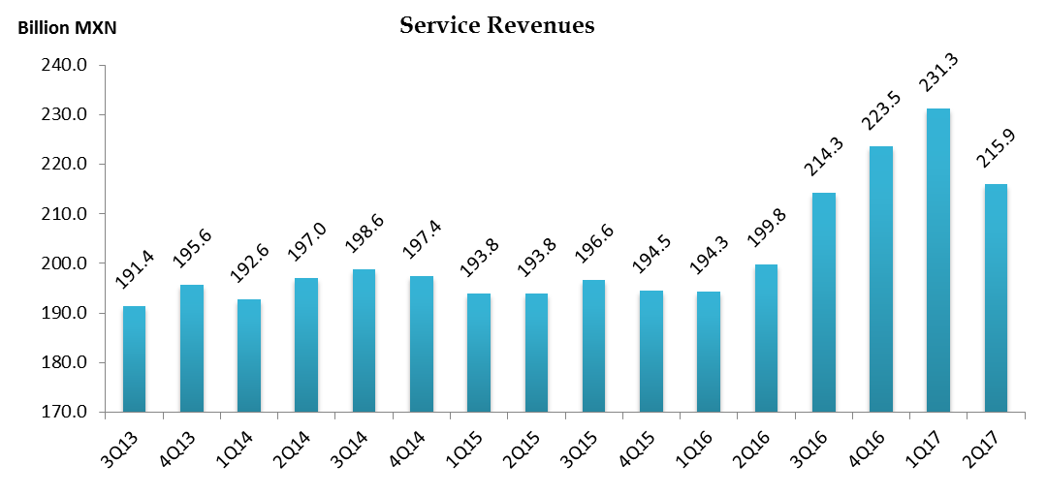
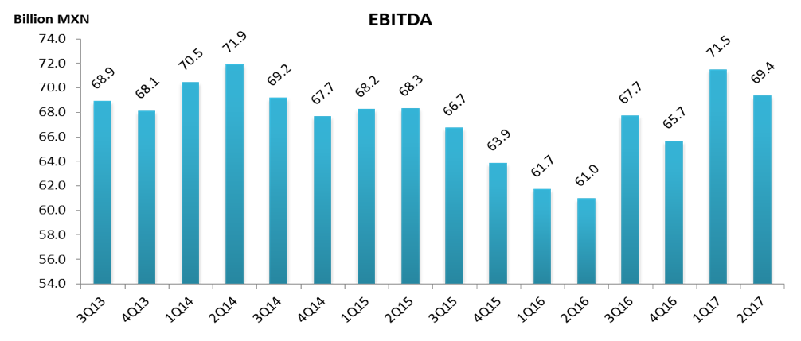
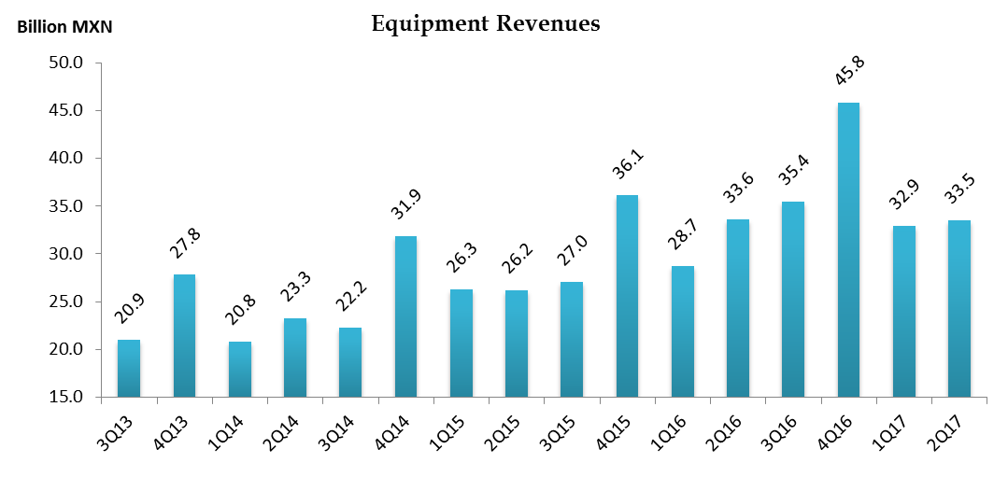

The Financials sector continues to post low and attractive multiples compared its historical average based on the last-twelve-months (LTM) price/earnings multiple. Financial sector net income increased 20% in 2Q17 on a LTM basis. Net income is expected to grow 22% by end 2017 while growth for 2018 is projected at 19%. The financial sector continues to gain traction from supportive macro fundamentals, such as a low unemployment rate, while loan growth is expected to stabilize in a 9% to 10% range. Sound macro fundamentals have translated into a low Non-Performing Loan ratio and relatively low write-offs as percentage of the loan portfolio.

Financial Sector Allocation
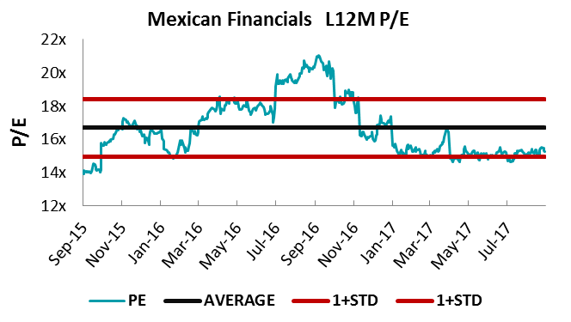
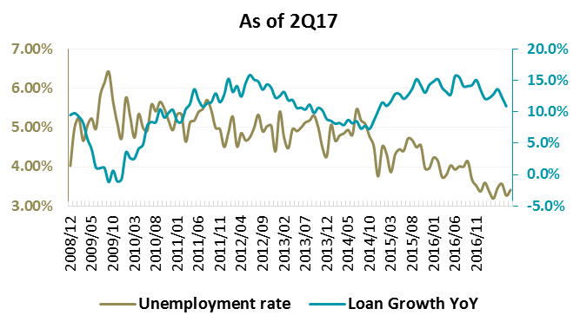
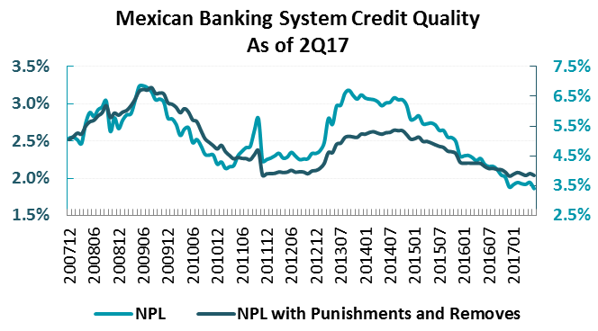
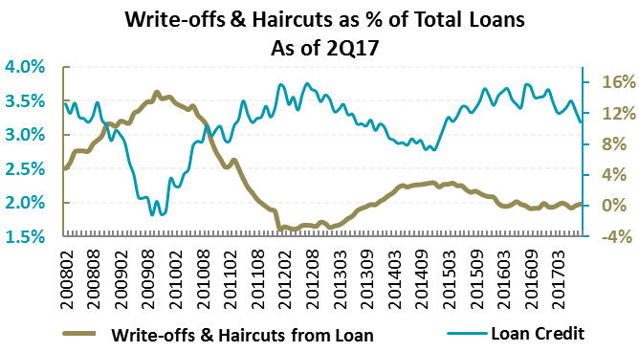

Financial Sector Allocation: Banks
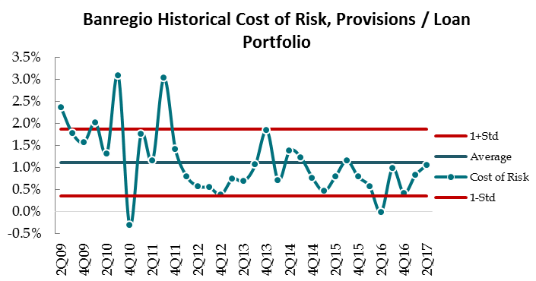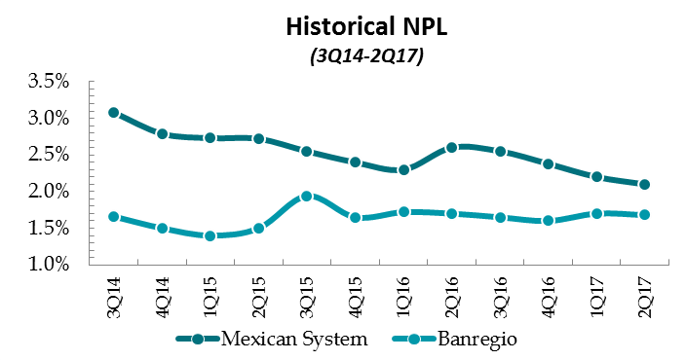

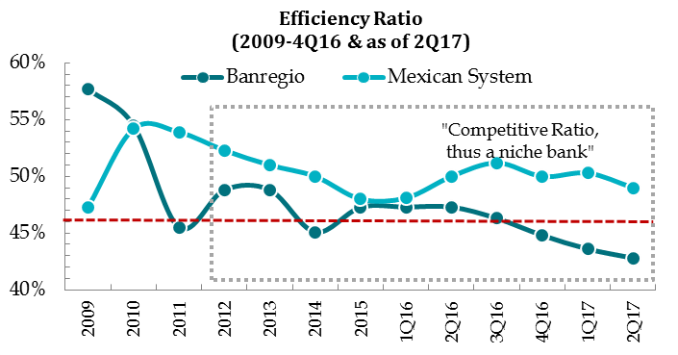
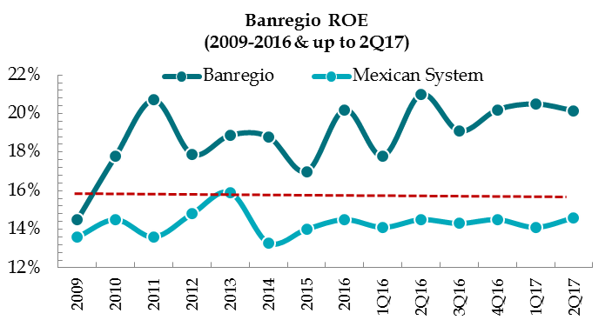
The Materials sector (specifically mining) has benefited from a recovery in industrial metal prices, while in the case of construction materials, high utilization rates have underpinned the price recovery strategy.

GMEXICO Financial Results as of 2Q17
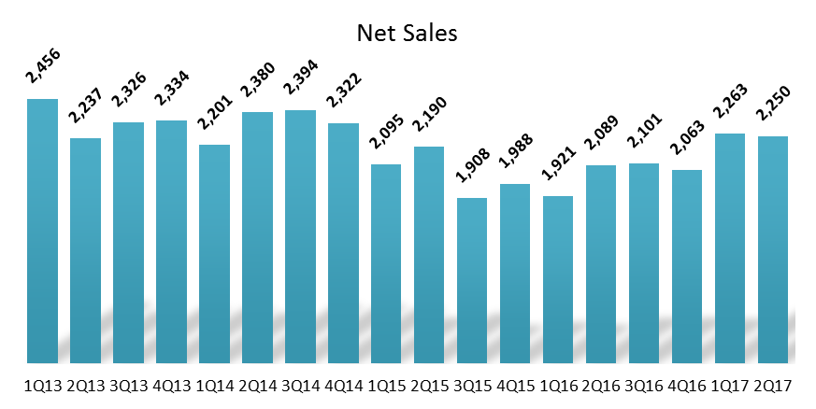
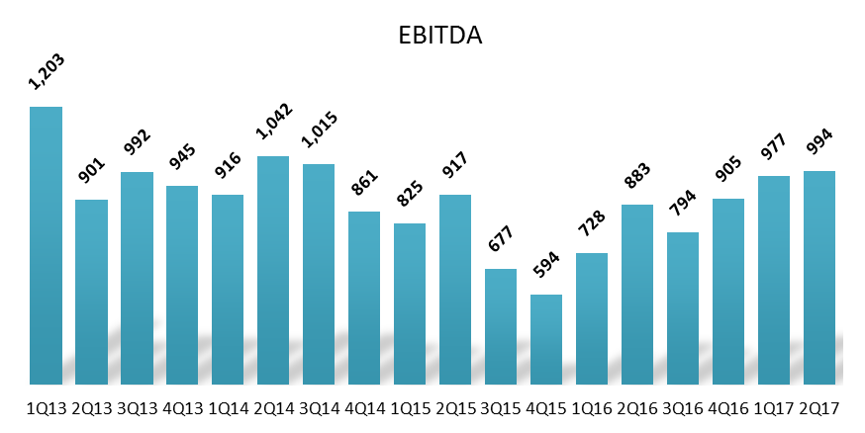

PE&OLES* Financial Results as of 2Q17
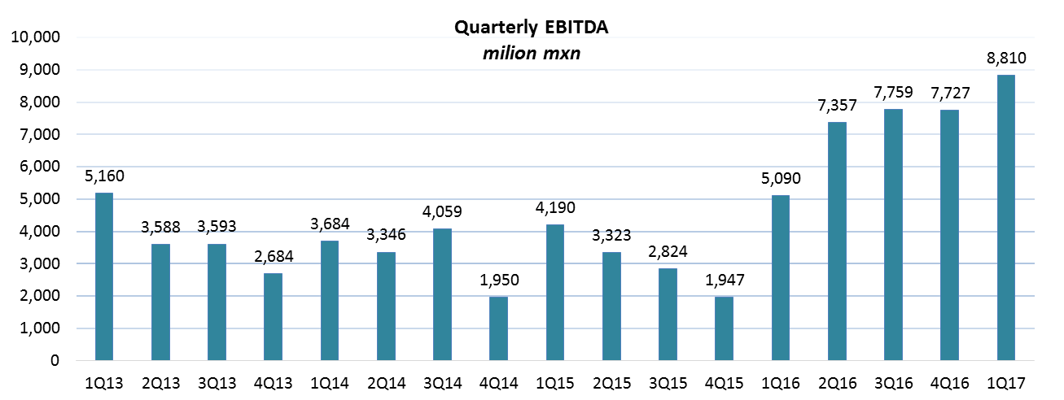
CEMEX Financial Results as of 2Q’17 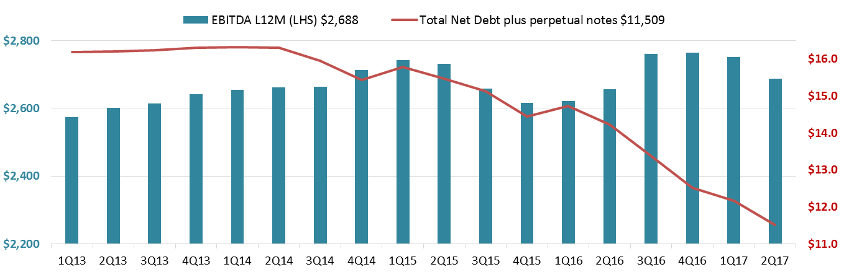
CEMEX Trailing 12-Month EBITDA by Regions. Million USD
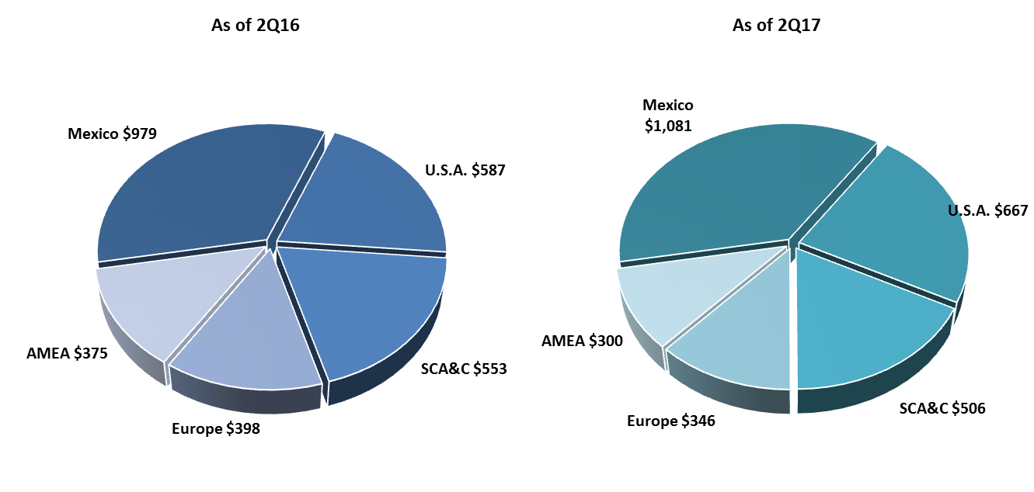
By selected stocks, the largest contributors in the LTM period ended July 31, were AMXL, +3.81%, GFNORTEO, +1.95%, and CEMEXCPO, +1.60%, while the largest detractors were ALPEKA, -0.93%, and ALFAA, -0.85%.
America Móvil (AMXL) reported a 21% y/y increase in mobile data revenues, which accounted for 33.5% of LTM consolidated revenues at the close of the second quarter of 2017, thus making it the largest source of revenues and a future growth driver. Mobile data consumption has led to a recovery in most regions’ ARPUs, a trend that is expected to continue as smartphone penetration boosts data demand. Regulatory easing measures in the company’s home and main market has also improved market perception. With a 57.5% return for the LTM period, AMX was the largest contributor to the Fund’s performance (+4.38%) and the biggest weight in the portfolio as of July 31, 2017.
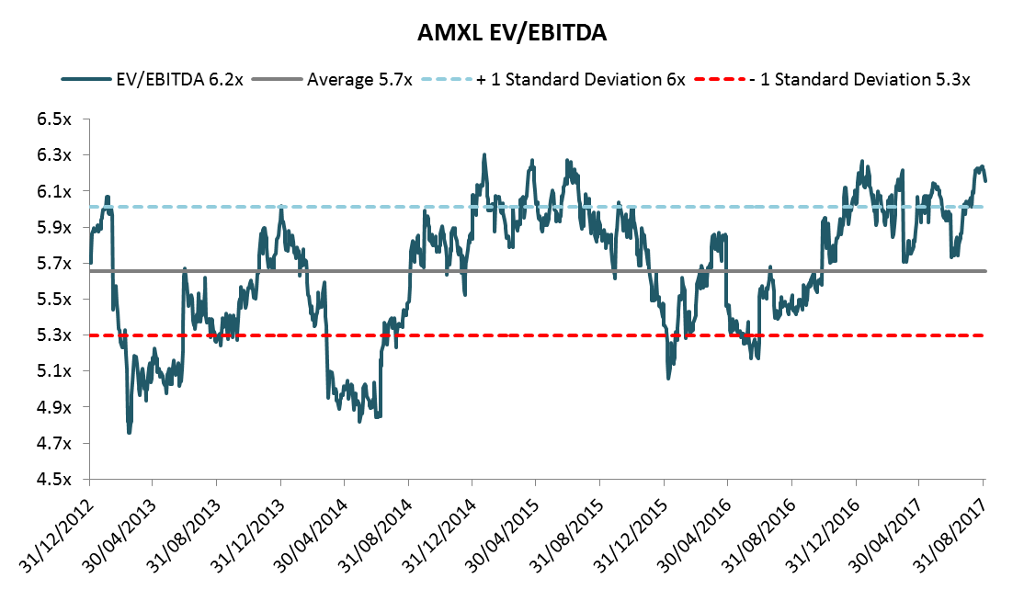
BANREGIO (GFNORTEO) maintained a positive NPL trend relative to the Mexican financial system, while its efficiency ratio remains positive and superior to the system. Past investments should generate higher earnings as administrative expenses related to new offices decrease. There are still some near-term growth drivers for ROE.
CEMEX (CEMEXCPO) is currently undertaking a financial reengineering that includes: i) a debt reduction plan with Net Debt/EBITDA reaching 4.3x as at 2Q, down from an all-time high of 7x; ii) a new loan facility agreement for US$4.05 billion under improved conditions that extends the debt schedule and lowers its cost while increasing the company’s flexibility to incur debt, pay dividends, and make new investments, which could improve FCF generation and put CEMEX on track to achieving investment grade by 2018; iii) a cement price increase of up to 20% in Mexico: 9% for ready mix, and 14% for aggregates; in the U.S, cement prices rose 3%, following increases in California and the South Atlantic region in April. The risks to investment grade are: i) volumes, particularly in Colombia; ii) slowing global economic growth and government infrastructure plans, and iii) Egypt’s lagging economy.
ALPEKA registered a negative US dollar return of -35.3% for the one-year period to July 31, 2017, and a negative return of -38.6% in Mexican Pesos. The stock’s negative performance can be mainly explained by weaker-than-expected operating results (raw material volatility) and 2017 guidance that was USD 100 million below consensus expectations. We maintained the position, as the end of the higher capital expenditure cycle will likely boost free cash flow generation, and the divestiture of its two cogeneration plants (Cosoleacaque & Altamira) could imply US$ 1.2 bn dollars at 10x EV/EBITDA. ALPEKA invested approximately US$ 490 mn.
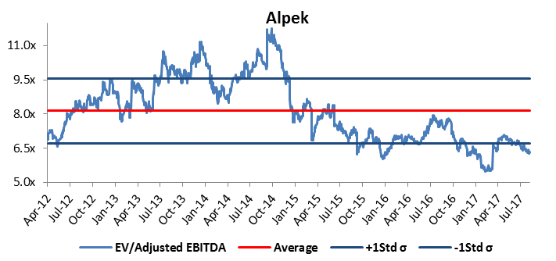
ALFAA’s negative performance was mainly due to the relatively weaker operating results of its petrochemical and automotive subsidiaries, noise from the NAFTA renegotiation and exchange rate volatility. In the case of Alfa, we decided to gradually increase the position to levels of 3.19% and 4.62%, 11% and 61% higher than the average cost of the issuer during the one-year period ended July 31, 2017.
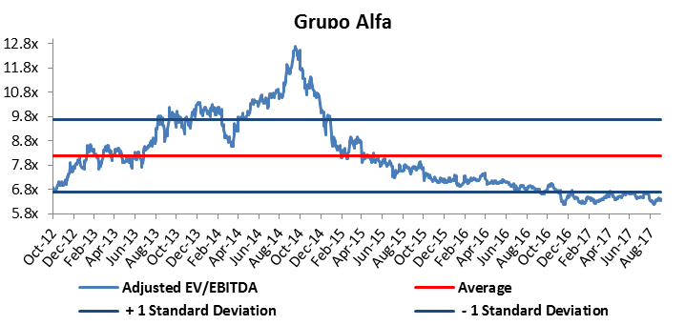
The main changes to portfolio allocation by sectors consisted of a -320 bp reduction in Materials and a 206 bp increase in Consumer Staples, at the end of July 31, 2017.

  - If not already covered, please could you take us through:
    - Positive stock selection in the Consumer Discretionary sector;
An attractive entry point opened up in Liverpool following a strong correction and inflationary pressure easing. M&A activity should boost FCF (Suburbia´s absorption), and the company remains the third largest credit card issuer in Mexico after the country’s two largest financial groups, Bancomer and Banamex. Liverpool has a solid management and sound corporate governance. Alsea is a similar story. We added La Comer for its attractive valuation.

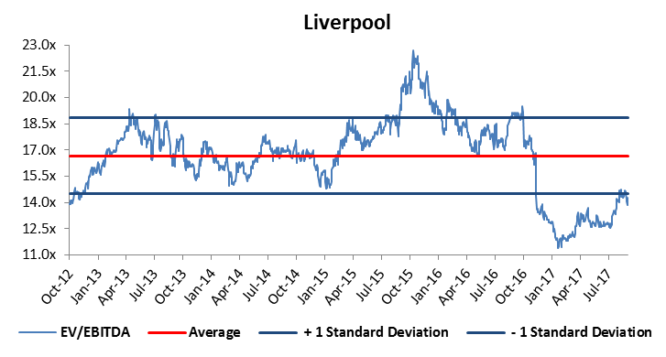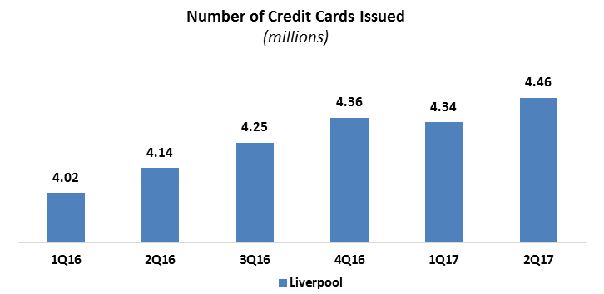
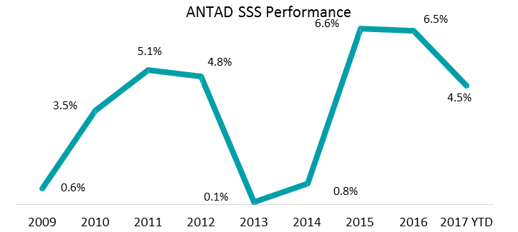

    - Negative stock selection in the Industrials sector:

For ALFAA, please see subsection “E” in answer 1.1.
VOLARA’s negative performance was due to the depreciation of the Mexican Peso, mainly because 60% of operating costs are in dollars, but only 30% of revenues. This currency mismatch puts pressure on operating margins.

Mexican Peso Performance
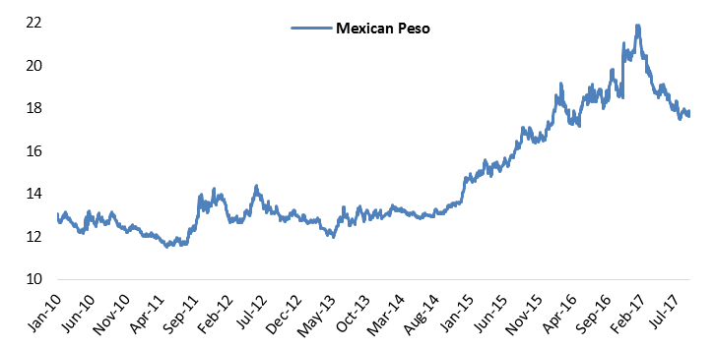

VOLARA Operating Expenses
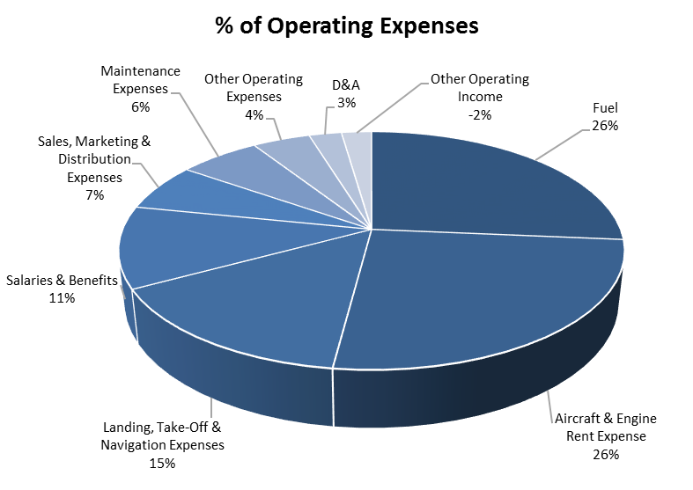

We have decided to maintain the position, mainly due to:
- Our year-end FX forecast (in a 17.50-18.20 range)
- International oil prices will likely remain in a US$ 40 - 60 range
- Double-digit (15% on average) passenger growth traffic
- VOLARA‘s industry (low cost carrier) is in the early stage of its economic growth cycle
- Sound management that is responding to new routes point to point.
- A solid balance sheet in US$.

The risks are:
- Forex
- Capacity – seat oversupply
- International oil prices
- Price war in the most frequent routes.

    - The performance of America Movil, Alpek, and Nemak?
Please see answer in 1.1. for America Movil & Alpek.
NEMAKA registered a negative US Dollar return of -24.3% one-year period ended July 31, 2017, and a negative return of -20.2% in Mexican Pesos with an average position of 1.14% during the period. The stock’s negative performance can be mainly attributed to noise surrounding the NAFTA renegotiation, a slowdown in the US automotive industry cycle, weaker-than-expected operating results (a metal price lag) and the adjustment of 2017 guidance due to lower volumes in North America.
NEMAKA Adjusted EV/EBITDA
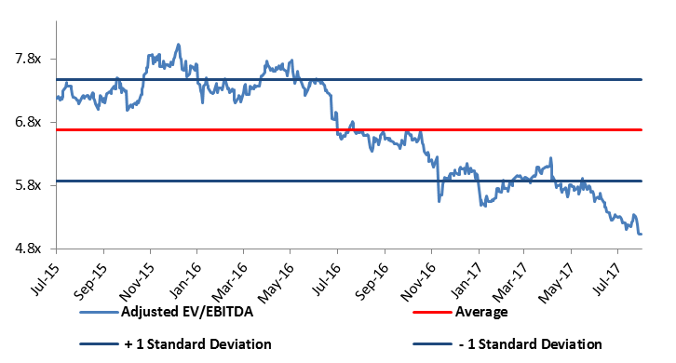
NEMAKA Historic Aluminum Price
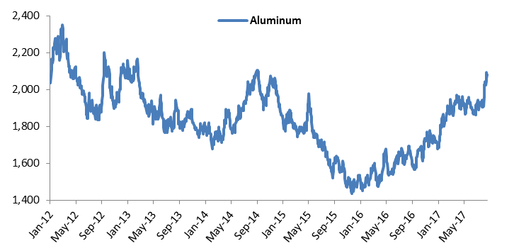

  - How did the Fund’s defensive stocks perform as the Mexican market fell between Oct-2016 and Jan-2017, and how did this compare to the team’s expectations?
Defensive stocks in the Fund’s Top Ten Holdings were GRUMA, IENOVA, MEXCHEM, GMEXICO, and CEMEX. We maintain most of the positions and in cases like GRUMA, CEMEX, MEXCHEM and GMEXICO, opted to increase positions, mainly due to their U.S. Dollar/Euro revenue. Even though some of these names have a cyclical component, they have a large revenue structure outside of Mexico. We also maintained AMX, as explained in 1.1. We kept GFNORTEO, GFREGIO, and PINFRA in the Fund’s top ten holdings. The only position we lowered was WALMEX due to lower projected Same Store Sales growth expectations compared to long-term historical growth.
- Portfolio structure & stats
  - What are the key investment themes and how has the team positioned the portfolio to benefit from them?
THE MXE’S INVESTMENT STRATEGY & ASSET CATEGORIES AS CLASSIFIED BY PAM
We have continued to adhere the Fund to our investment strategy using a value approach, a de-indexed strategy and flexible investment themes within the following asset categories:
- Growth companies: these companies are characterized by Merger & Acquisition activity and resilient profit & loss statement top lines, primarily due to management efficiencies that have resulted in margin expansion. Companies with a net US Dollar revenue component are also included in this asset category.
- Total annual return companies with an annual dividend yield and share repurchase policy, sound financials and sound corporate governance.
- Special situation companies, mainly oversold stocks, usually with a high discount to equity due to strategic vertical integration at the end of a high Capital Expenditure (CapEx) cycle and facing challenging commodity-petrochemical momentum. This category also includes small capitalization companies of below US $1 billion and non-trapped value companies with sound corporate governance and accounting.
- Energy-related companies, mainly natural gas and cogeneration.
The Fund’s main overweight relative to the Mexbol Index at the end of the Fund’s fiscal year on July 31, 2017, was:
- Industrials, +145 basis points (bp), mainly due to conglomerates with an attractive discount to their intrinsic future value based on PAM’s SOTPs or DCF valuation, including toll road concessions and consumption (multiline retail, cold cuts, and dairy). (Source: PAM and Bloomberg).
- Materials, +330 bp, a sector that has benefited from a recovery in industrial metal prices in the case of Mining, while in the case of construction materials, high utilization rates have supported the price recovery strategy. The Fund also includes growing Chemical and Petrochemical companies with organic and inorganic growth in this category. (Source: PAM and Bloomberg).
The Fund’s major underweight positions relative to the Mexbol Index at the end of the Fund’s fiscal year on July 31, 2017, were:
- Consumer Staples, -1004 bp, as stocks in this category are fairly valued. Approximately 40% of MEXBOL constituents are consumption related, according to Bloomberg. (Source: PAM and Bloomberg).
- Telecommunication Services, -174 bp, due to limited upside to our target price and the fact that a positive operating results growth trend is likely priced into all-time high valuations for the one-year period ended July 31, 2017. (Source: PAM; Bloomberg).

MXE Portfolio & Mexbol Mexico-Index
Source: PAM and Bloomberg.

  - What were the largest changes to the portfolio over the year and what was the rationale?
We increased exposure to materials via CEMEX (an attractive FCF yield and a growth story in its main markets due to pricing and the possibility of achieving investment grade); GMEXICOB (a large discount to its NAV and solid copper outlook); MEXCHEM (pricing power, as a lack of supply has resulted in high utilization capacity in the bulk of its business segments, and sound demand for its products in Europe); Financials via GFREGIO, BBAJIO, GFINTERO, either on good earnings momentum underpinned by higher interest rates or very attractive valuations and growth (GFINTERO). We also added consumer names selectively, LIVEPOLC /LACOMER. ALFA is one of our large positions given the discount to NAV and a vehicle for buying SIGMA at very attractive valuations. We also increased the position in IENOVA on a very attractive backlog of projects, current growth and US dollar exposure, and used price opportunities to add AMX and GCARSO.
We lowered positions in stocks that were closer to their fair valuation based on our valuation models, including ALSEA, AC*, WALMEX, OMA and GAP. While we like these stories, the upside potential was limited. We also lowered positions in NEMAKA, as its U.S. outlook has become more challenging and the position was less than 1.5%.

Major Changes in basis points following our Investment Strategy.
One Year to July 31, 2017.
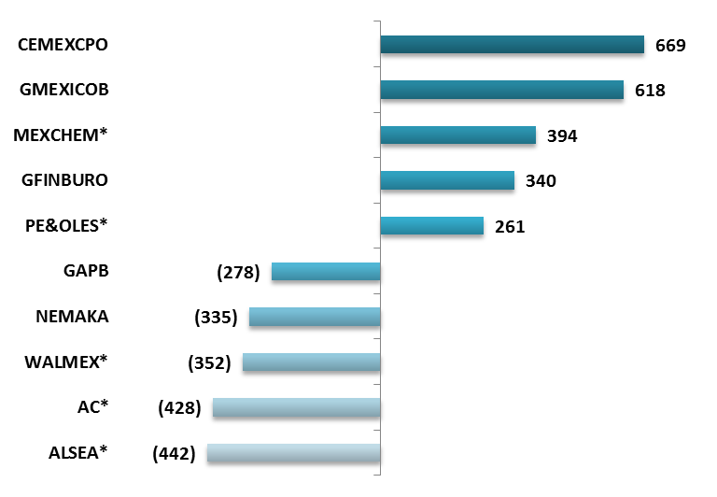
Source: PAM and Bloomberg.
  - How have valuations changed over the year and how has MXE taken advantage of any anomalies?
Valuations have increased on the back of sound earnings growth in 2017. Prior to and during the U.S. election, the fund took advantage of buying oversold stocks (i.e. Rassini) on thematic issues (NAFTA, for example) rather than concrete or fundamental news. We also built positions in names with relatively low risk and attractive valuations due to a market sell-off (financial sector stocks and Arca Contal).
On a sample basis, MEXBOL valuations have reached historical average levels, so our stock picking has become quite selective.
MEXBOL Index Forward P/E Ratio 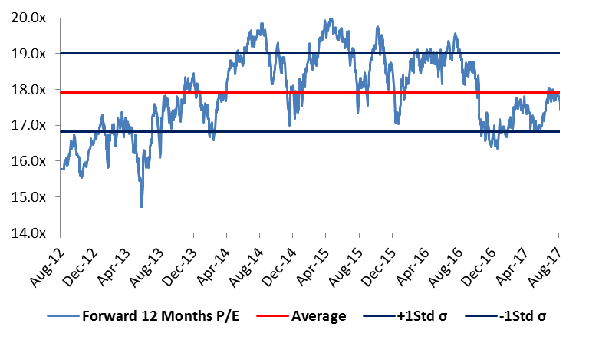
  - If not already covered, what is the Fund’s total exposure to the special situation asset class?
The Fund’s current exposure to the special situation asset category accounts for approximately 15.0% of the Fund’s total assets. The main companies in this asset class are: i) VESTA, 2.88%, a high-growth company with a strong management, primarily engaged in the construction of local industrial parks in regions where economic growth is 5-6% per annum. The Industrial Parks are built-to-suit (logistic and manufacturing sectors (aerospace, consumption manufacturing-plastics, and autos, etc.); ii) ALFA, 4.62%, a company that manages a portfolio of diversified subsidiaries that capture growth opportunities from current and related businesses, either organically or through acquisitions; iii) GFINTERO, 2.00%, a specialty financial group focused on loans for the government and infrastructure projects that was bought at an attractive valuation close to its price to book value with potential M&A activity; and iv) LACOMUBC, 1.49%, a company that operates in the Mexican retail sector serving different groups of consumers through four different specialty-store formats
In addition to your question, we include certain stocks the portfolio has avoided during the fiscal year period ended July 31, 2017, due to weak corporate governance and large family stakes.

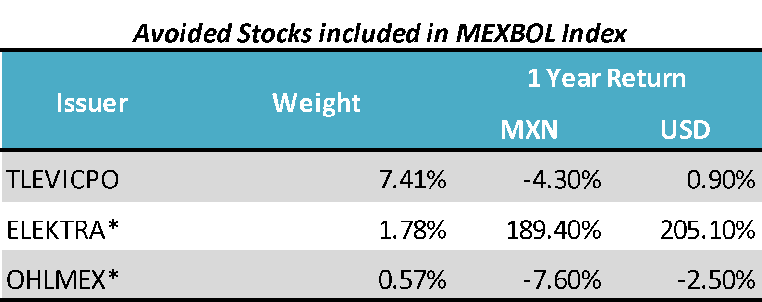
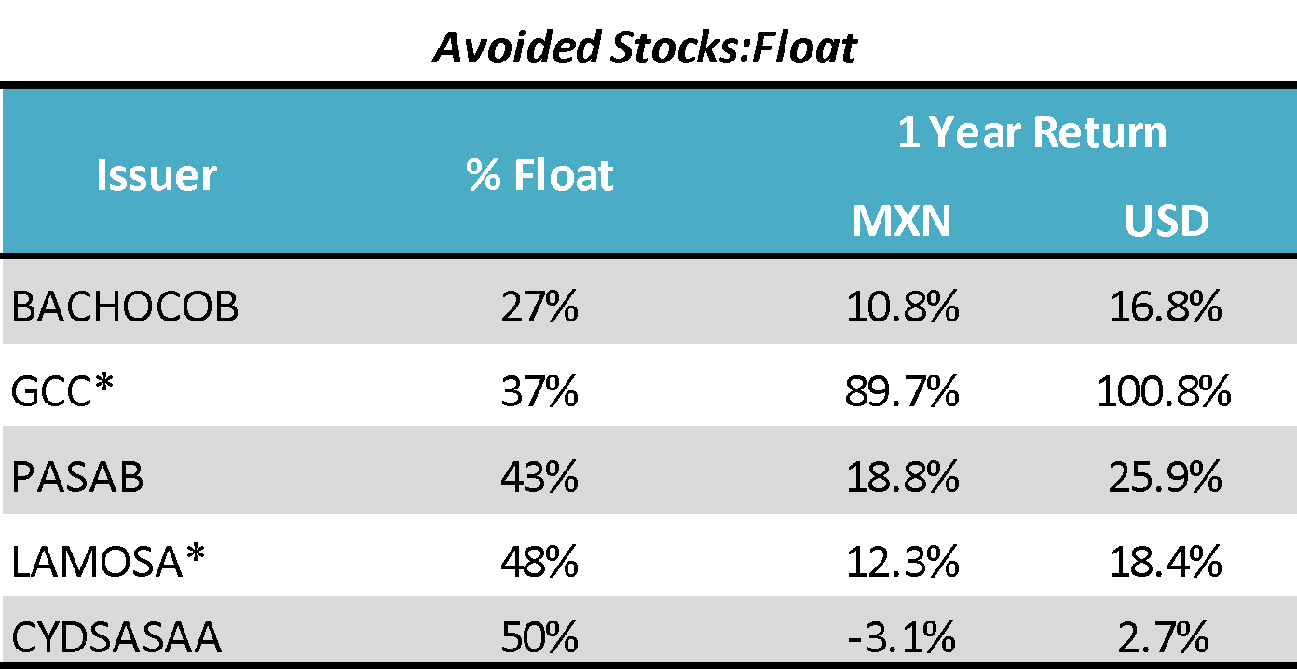

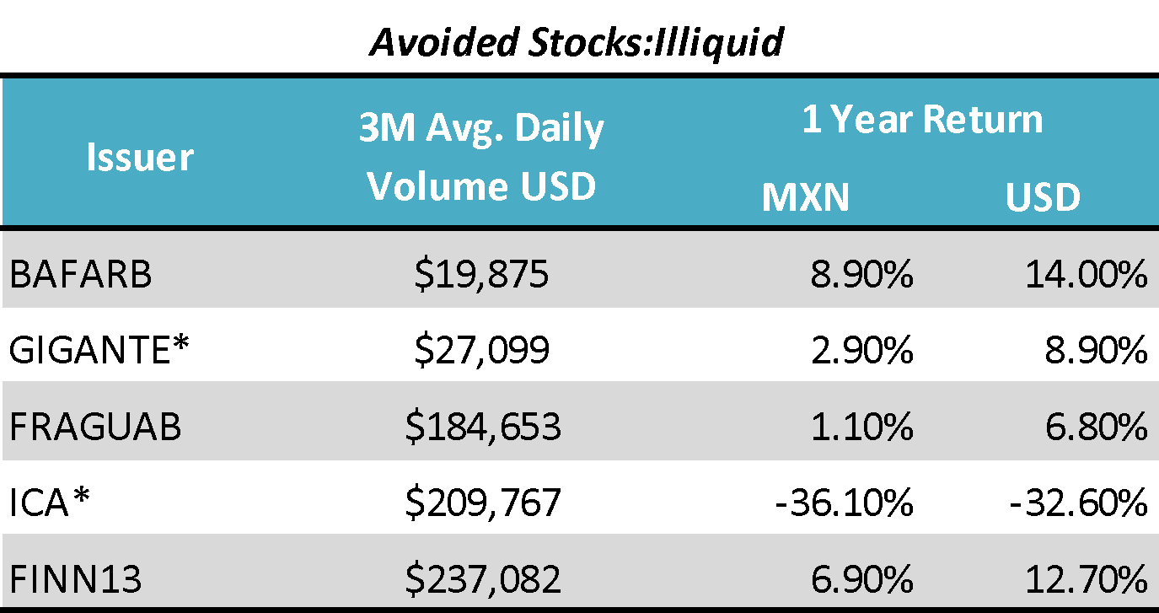

  - Please provide a quick summary of the team’s macro outlook, including the expectations for the NAFTA negotiations, currency, and the 2018 election?
The main feature of the Mexican economy in 2017 has been the upward revision of economic growth forecasts. At the beginning of the year, there were doubts that the Mexican economy could reach a 1% annual growth rate. So far, however, growth expectations fluctuate around 1.9%, 1.6% being the worst-case scenario. The growth engines have been resilient domestic consumption –supported by robust formal employment and bank credit expansion numbers– and a recovery in foreign trade accounts –July figures show an accumulated surplus of more than 40 billion dollars with the US that compares favorably with annual figures of 60 billion dollars.
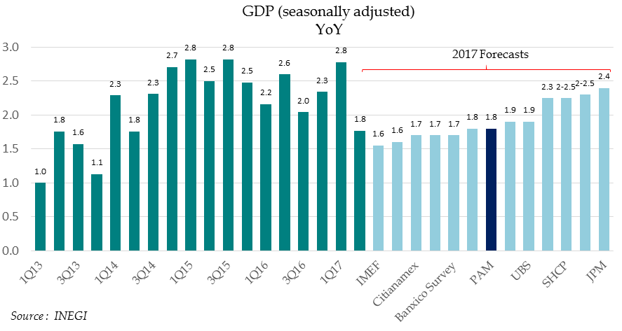
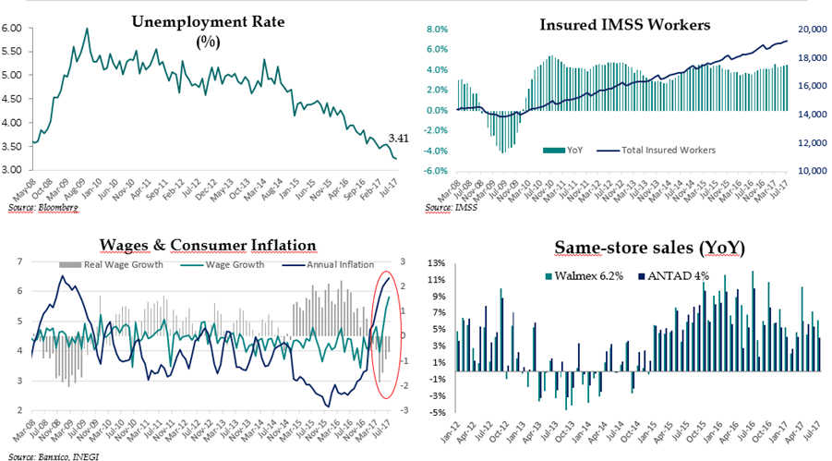
NAFTA negotiations appear to be on the right track. At the beginning of the year there were categorical statements from Donald Trump about withdrawing the US from the agreement; so far, two of the three negotiation rounds have taken place and the U.S. and Mexican governments have incentives to achieve a general agreement before the beginning of key elections in both countries in 2018. 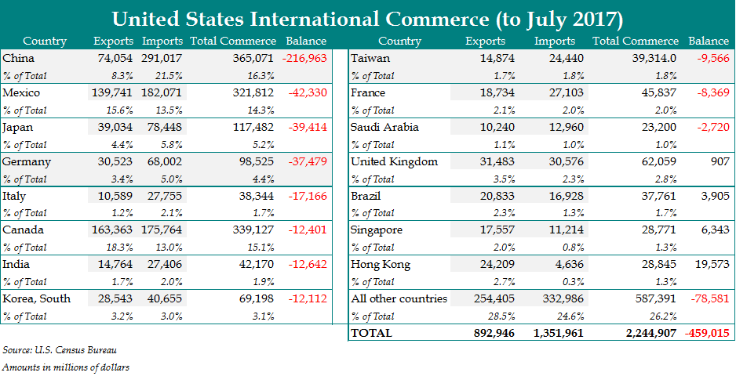

Energy Reform and healthy public finances are two further “success stories” regarding the Mexican Economy in 2017. So far, Energy Reform has generated 41 billion dollars of foreign investment for the sector in the coming years. According to Mexican government estimates, after the second round of auctions, committed foreign investment could generate 80 billion dollars. At the same time, the correction of the government’s fiscal deficit has led Standard & Poor’s and Fitch rating agencies to improve their outlook on Mexican sovereign debt –currently three notches above investment grade– from negative to stable.

These sound economic fundamentals have resulted in the Mexican peso appreciating by nearly 20% against the U.S. dollar in the first 8 and a half months of 2017. The peso/dollar exchange rate could fluctuate around 18 pesos per dollar in the coming months. However, according to our base-case scenario, once the NAFTA negotiations and 2018 presidential elections are favorably resolved, there should be room for further appreciation of the Mexican peso, so the exchange may even reach 15 pesos per US dollar in the second half of 2018.
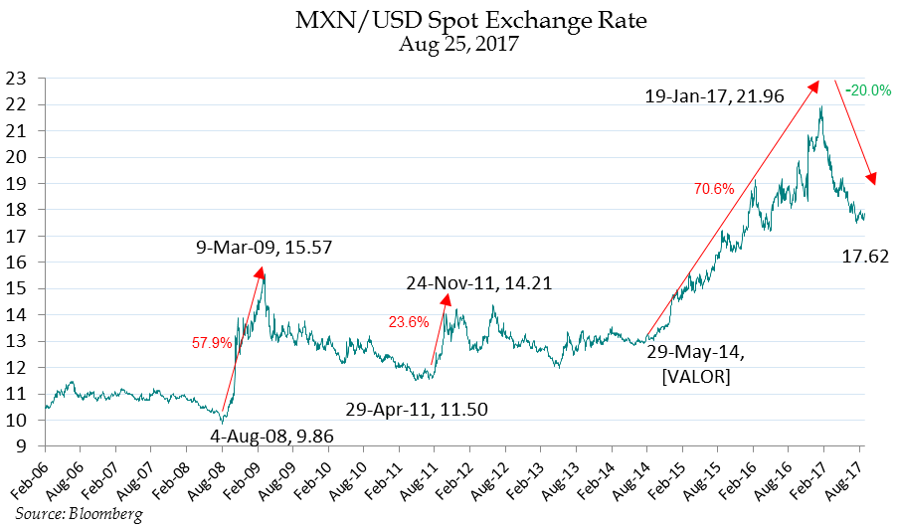
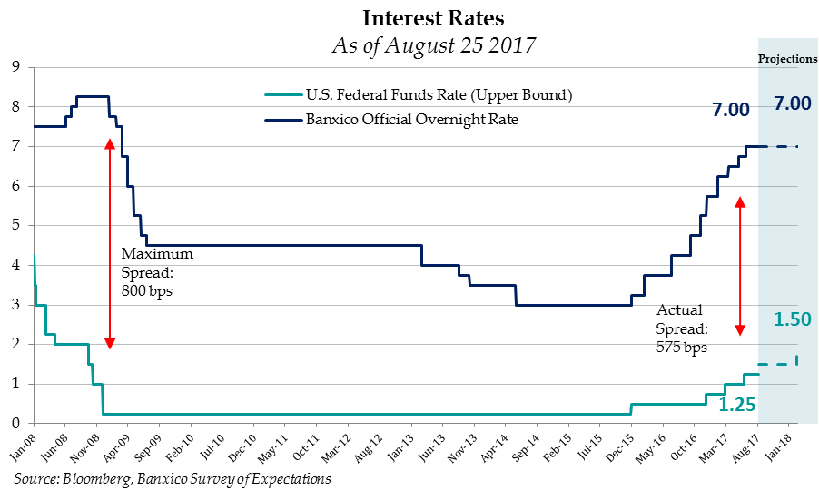
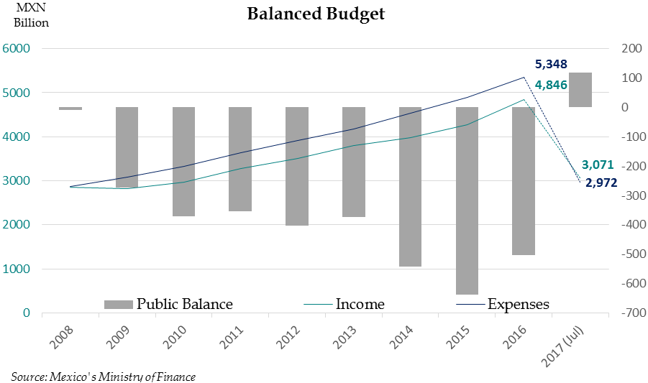
An 8.2 earthquake on the Richter scale recently struck Mexico, leaving more than 100 hundred casualties and wrecking damage in two poor states in the south of the country. Mexico City was unscathed. A similar earthquake in 1985 left 10,000 casualties and devastated Mexico City. This is a clear illustration of the structural progress Mexico has achieved in recent years.

